React Router v6 and Web Animation API

**ANIMATION:**

Movement of the object now for aanimation Web animation API

ANNIMATION LINK:

<https://developer.mozilla.org/en-US/docs/Web/API/Web_Animations_API/Using_the_Web_Animations_API>

<https://github.com/web-animations/web-animations-js/blob/dev/docs/examples.md>

<https://developer.mozilla.org/en-US/docs/Web/API/Web_Animations_API/Web_Animations_API_Concepts>

WAAPI = web animation API

Its take two parameter (one is pic or farmes etc and second is timing or behiviour)

ele.animate([],{}) // and ye function phle paramenter main array and dosare main object leta hai

var ele=document.getElementById('main');

// ele.animate([],{}) actual asa hai

ele.animate([

{transform:'translate(0,0)'}, // take two 0 0 first 0 is x axis and second 0 is y-axis and

//yahan lagan trastale mean move ho start ho 0 0 se

{transform:'translate(600px,0)'}, // move 600px x-axis

{transform:'translate(0,0)'}, // moave back to zero

],

{

    duration: 1500, // 15 miliseond

    iterations:Infinity // infinity main rahe ga

})

Sab main baraber ke or equal property hone chahe

FOR EVENT HANDLING ye importat pic hai multipal event you can see:

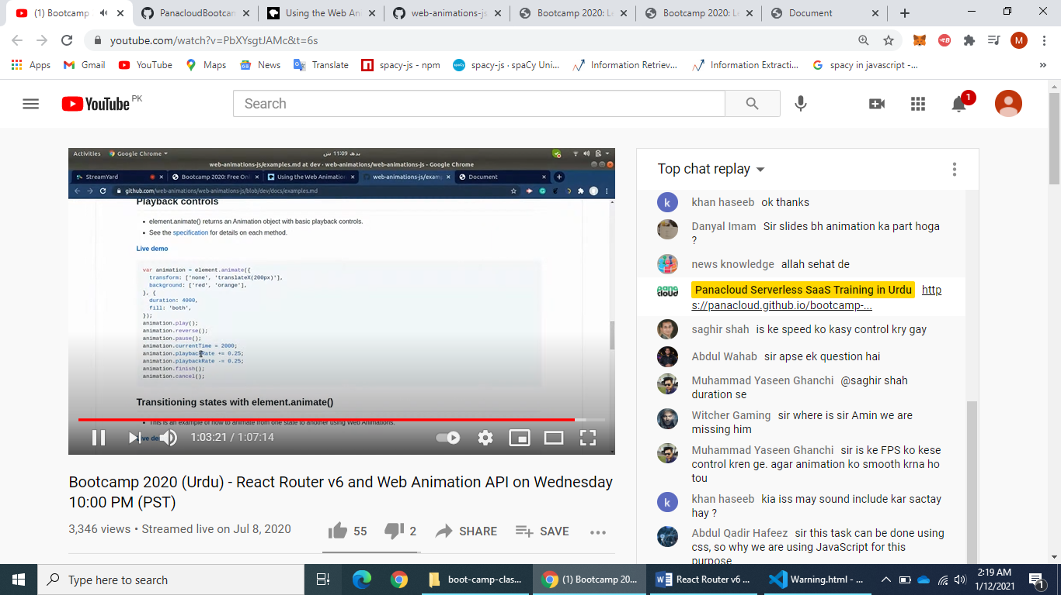

EXTRA:

For mouse click and up stop and resume

     document.addEventListener("mousedown",()=>{

            setannimation.pause(); // on mouse click stop ho je ga

        })

        document.addEventListener("mouseup",()=>{

            setannimation.play(); // on mouse click resume ho je ga

        })